**Test a Perceptual Phenomenon**

**By**

**Dogan Askan**

**Background Information**

In a Stroop task, participants are presented with a list of words, with each word displayed in a color of ink. The participant’s task is to say out loud the color of the ink in which the word is printed. The task has two conditions: a congruent words condition, and an incongruent words condition. In the congruent words condition, the words being displayed are color words whose names match the colors in which they are printed: for example RED, BLUE. In the incongruent words condition, the words displayed are color words whose names do not match the colors in which they are printed: for example PURPLE, ORANGE. In each case, we measure the time it takes to name the ink colors in equally-sized lists. Each participant will go through and record a time from each condition.

**Questions for Investigation**

1. What is our independent variable? What is our dependent variable?

Independent variable is a list of words, with each word displayed in a color of ink. Color and name of words match in congruent words condition and does not match in incongruent words condition. Dependent variable is the time it takes to name the ink colors in equally-sized lists in both conditions.

1. What is an appropriate set of hypotheses for this task? What kind of statistical test do you expect to perform? Justify your choices.

Null hypothesis; population mean of time it takes to name the ink colors in the congruent list is equal or greater than the population mean of time to name the ink colors in the incongruent list.

Alternative hypothesis; population mean of time it takes to name the ink colors in the congruent list is less than the population mean of time it takes to name the ink colors in the incongruent list.

Mathematically,

$$H_{o}: μ_{c}≥μ_{i}$$

$$H_{a}: μ_{c}<μ_{i}$$

Where,

$μ_{c}$ = Population mean time it takes to name the ink colors in the congruent list.

$μ_{i}$ = Population mean time it takes to name the ink colors in the incongruent list.

Due to comparison the means of two related groups to detect whether one is statistically and significantly greater than the other, one tailed dependent t-test can be utilized to test the hypothesis by assuming industry standard alpha level as $α=.05$.

Assumptions,

* Samples come form same population by performing random sampling.
* Measurements are interval or ratio scale.
* The population is approximately normally distributed.
* Sample data can estimate population variance.

1. Report some descriptive statistics regarding this dataset. Include at least one measure of central tendency and at least one measure of variability.

Congruent Incongruent

Min. : 8.63 Min. :15.69

1st Qu.:11.90 1st Qu.:18.72

Median :14.36 Median :21.02

Mean :14.05 Mean :22.02

3rd Qu.:16.20 3rd Qu.:24.05

Max. :22.33 Max. :35.26

vars n sd trimmed mad range skew kurtosis se

Congruent 1 24 3.56 13.88 3.49 13.70 0.37 -0.62 0.73

Incongruent 2 24 4.80 21.29 3.89 19.57 1.36 1.52 0.98

1. Provide one or two visualizations that show the distribution of the sample data. Write one or two sentences noting what you observe about the plot or plots.

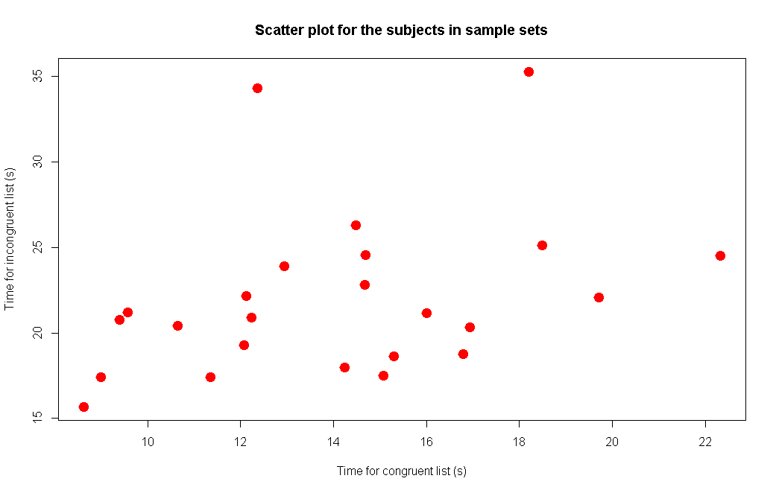

Above scatterplot shows that there may be a correlation between congruent and incongruent results, which it makes sense considering subject are same.

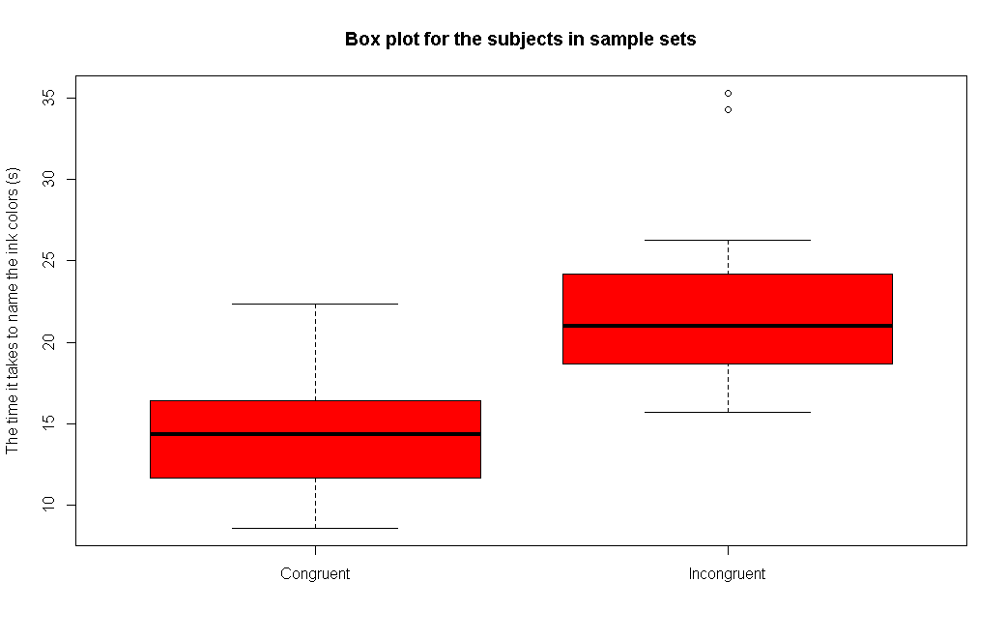

Above box plot notes that incongruent statistics are greater.

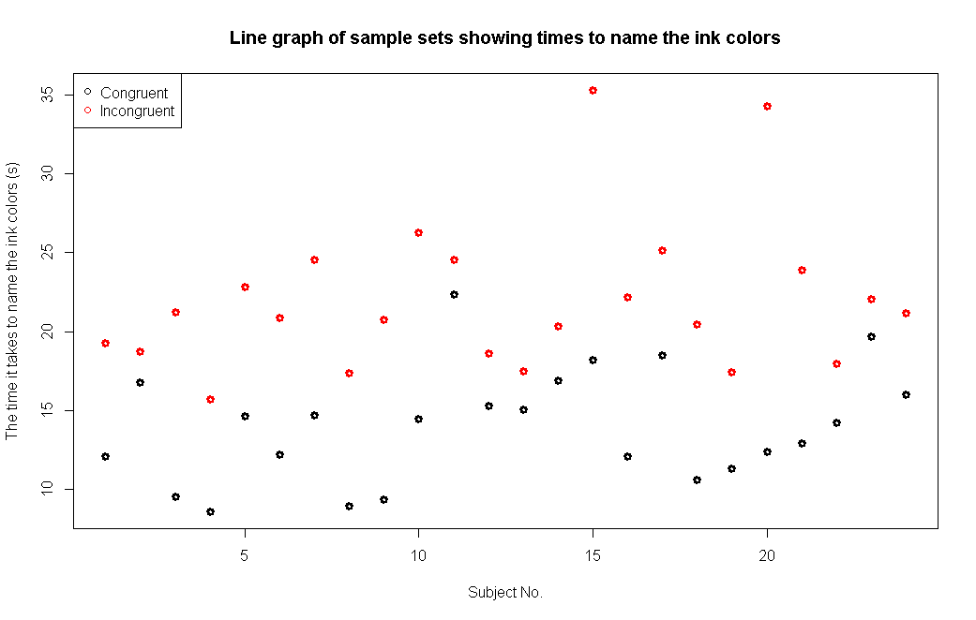

Above graph shows that all subjects finished incongruent lists in a longer time.

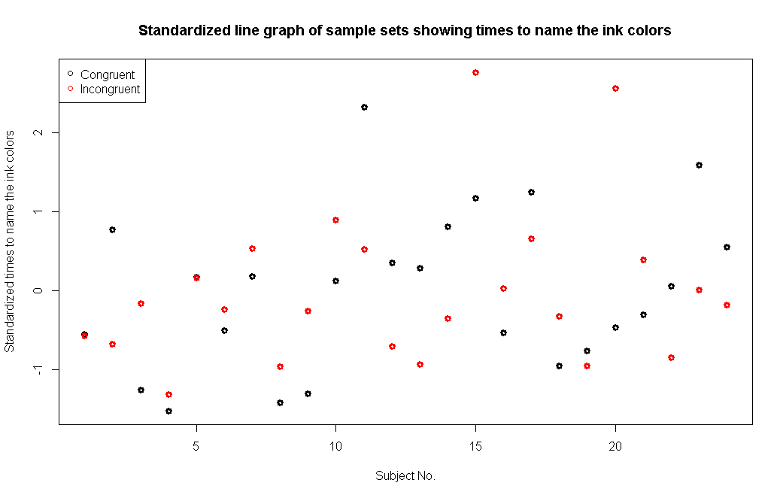

Above graph explains standardized values of data frame.

1. Now, perform the statistical test and report your results. What is your confidence level and your critical statistic value? Do you reject the null hypothesis or fail to reject it? Come to a conclusion in terms of the experiment task. Did the results match up with your expectations?

Paired T-test output with 95% confidence level can be seen below. One tailed t critical value is 1.714 at $α=.05$ and $df=23$. Since t-statistic(8.0207) > t-critical(1.714)[1], null hypothesis can be rejected at p-value << 0.05.

Paired t-test

data: df$Incongruent and df$Congruent

t = 8.0207, df = 23, p-value = 4.103e-08

alternative hypothesis: true difference in means is not equal to 0

95 percent confidence interval:

5.910555 10.019028

sample estimates:

mean of the differences

7.964792

And, there is a statistically significant evidence that population mean of time it takes to name the ink colors in the congruent list is less than the population mean of time it takes to name the ink colors in the incongruent list according to the this sample dataset. This result match with initial expectations.

1. Optional: What do you think is responsible for the effects observed? Can you think of an alternative or similar task that would result in a similar effect? Some research about the problem will be helpful for thinking about these two questions!

There some theories behind this effect [2].

Processing speed: This theory suggests there is a lag in the brain's ability to recognize the color of the word since the brain reads words faster than it recognizes colors. This is based on the idea that word processing is significantly faster than color processing. In a condition where there is a conflict regarding words and colors (e.g. Stroop test), if the task is to report the color, the word information arrives at the decision-making stage before the color information which presents processing confusion. Conversely, if the task is to report the word, because color information lags after word information, a decision can be made ahead of the conflicting information.

Selective attention: The Selective Attention Theory that color recognition as opposed to reading a word, requires more attention, the brain needs to use more attention to recognize a color than to word encoding, so it takes a little longer. The responses lend much to the interference noted in the Stroop task. This may be a result of either an allocation of attention to the responses or to a greater inhibition of distractors that are not appropriate responses.

Automaticity: This theory is the most common theory of the Stroop effect. It suggests that since recognizing colors is not an “automatic process” there is hesitancy to respond; whereas, the brain automatically understands the meaning of words as a result of habitual reading. This idea is based on the premise that automatic reading does not need controlled attention, but still uses enough attentional resources to reduce the amount of attention accessible for color information processing. Stirling (1979) introduced the concept of response automaticity. He demonstrated that changing the responses from colored words to letters that were not part of the colored words increased reaction time while reducing Stroop interference.

Parallel distributed processing: This theory suggests that as the brain analyzes information, different and specific pathways are developed for different tasks. Some pathways, such as reading, are stronger than others, therefore, it is the strength of the pathway and not the speed of the pathway that is important. In addition, automaticity is a function of the strength of each pathway, hence, when two pathways are activated simultaneously in the Stroop effect, interference occurs between the stronger (word reading) path and the weaker (color naming) path, more specifically when the pathway that leads to the response is the weaker pathway.

**References**

[1] Udacity, “ST095 Course Index” accessed June 2016. [Online]. Available: <https://www.udacity.com/wiki/st095/courseindex>

[2] Wikipedia, “Stroop effect” accessed June 2016. [Online]. Available: <https://en.wikipedia.org/wiki/Stroop_effect>